Eastern Region

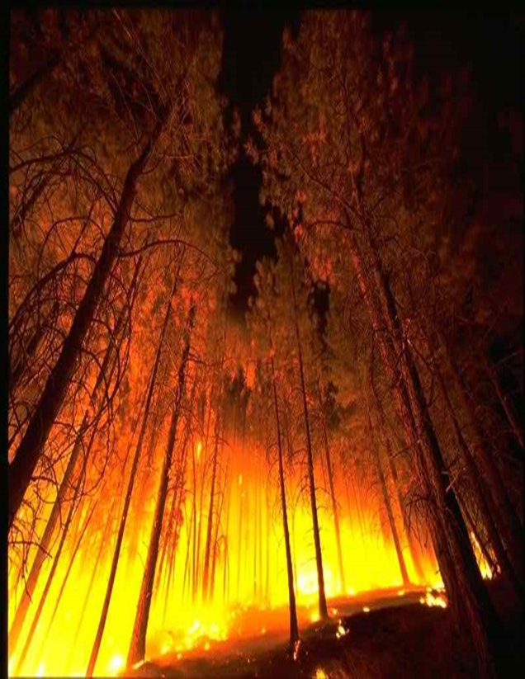
Quantitative Wildfire Risk Assessment (QWRA)
Highly Valued Resource and Asset (HVRA) Response Function Virtual Workshops

WHEN?
Dates | Participating States
Session #1:  February 2, 2021  **Workshop begins at 0900 CST/Ends at 1700 CST** | WEST-Missouri, Iowa, Michigan, Minnesota, Wisconsin, Illinois, Indiana
Session#2:  February 9, 2021  **Workshop begins at 1000 EST/Ends at 1700 EST** | EAST-Ohio, West Virginia, Pennsylvania, New York, Vermont, New Hampshire, Maine, Massachusetts, Rhode Island, Connecticut, New Jersey, Delaware, Maryland

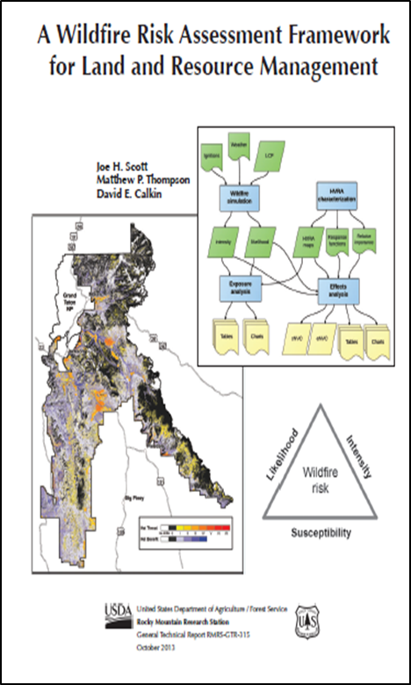
WHAT? The Highly Valued Resources and Assets (HVRA) Relative Importance (RI) Workshop is the third in a series of workshops in the Quantitative Wildfire Risk Assessment process. In this workshop, the susceptibility of each HVRA to wildfire of different intensities is characterized. The risk assessment process relies on an expert-defined “response function” which translates fire effects into value change, based upon fire intensity and sometimes other environmental characteristics or covariates. This workshop builds on a previous workshop in which the set of HVRA were identified and their spatial data assembled for this effort.
Response functions characterize both beneficial and negative responses to wildfire. Resources can experience a benefit, usually from low intensity fires (enhancing wildlife habitat, for example), while neutral or more negative responses might be expected at higher intensities. Assets, on the other hand, usually do not incur benefit from fire of any intensity. Response functions quantify the relative or percentage of value change (positive or negative) anticipated from fire for a given intensity class. There are six intensity classes used in this framework: 0-2 ft, 2-4 ft, 4-6 ft, 6-8 ft, 8-12 ft, and 12+ ft. Response functions are assigned for each intensity class and often span +100 to -100, with zero quantifying a neutral response.

WHO SHOULD ATTEND? The primary attendees are resource specialists and fire and fuel management staff with the knowledge to quantify fire effects at each of the intensity classes. Ideally, workshop attendees represent a variety of disciplinary backgrounds, particularly those familiar with the mix of HVRA selected for inclusion in the assessment.

This is an Interagency Event!

NEXT STEPS/HOW TO REGISTER?
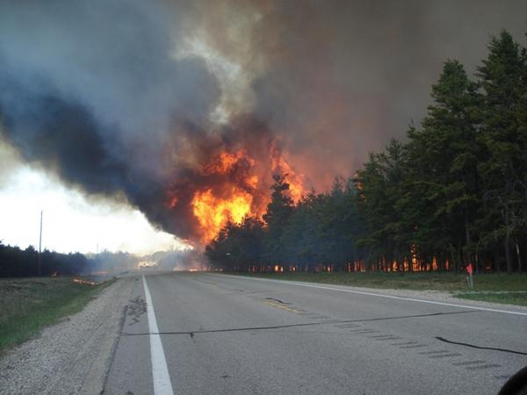
Send email to Brian Schaffler, USFS R9 Regional Fuels Program Manager at bschaffler@usda.gov and provide names and contact information (emails, phone number) of participants.
**Workshop Connection information (virtual platform link/conference call number) and an agenda will be provided to participants as the Workshop nears**

Scott, Joe H.; Thompson, Matthew P.; Calkin, David E. 2013. A wildfire risk assessment framework for land and resource management. Gen. Tech. Rep. RMRS-GTR-315. U.S. Department of Agriculture, Forest Service, Rocky Mountain Research Station. 83 p.

